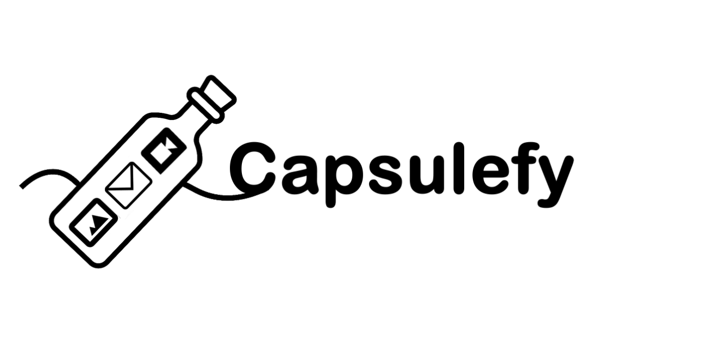

PROJECT LAUNCH DOCUMENTATION

Group 15

Email: [capsulefy.communications@gmail.com](mailto:capsulefy.communications@gmail.com)

Website: <https://capsulefy05.herokuapp.com>

GitHub: <https://github.com/pabreblob/capsulefy/releases> (Release 5)

Cantón Fernández, Adrián

Carpio Camacho, Daniel

Fresno Aranda, Rafael

Rebollo Lobo, Pablo

Rodríguez Regidor, Juan

Index

Introduction 1

Business Idea 2

Development team 2

Competitors analysis 3

Project Launch tasks 4

Week 1 (May 13th- May 19th) 4

Week 2(May 20th-May 25th) 5

Target users 5

Marketing campaign 6

Advertisement budget 6

Google ads budget 6

Facebook ads budget 7

Twitter ads budget 7

Total 7

Social media publications 7

Discounts and campaigns: 8

Cost estimation 8

GDPR 9

Expenses of the project so far 10

Feedback received from our pilot users 10

Future improvements 11

Devising a business plan milestone initial planning 11

Week 1 (May 27th- June 2nd) 11

Items produced as a result of this deliverable 12

# Introduction

The aim of this document is to provide information about the preparations that have been made in order to launch our product, as well as the results obtained from that. A quick overview of the business idea, team roles and costs is also provided, but for more extensive information about this topic please refer to the “Devising a project” document. For more information about the result of our development sprints, please refer to our sprint documents.

# Business Idea

Capsulefy is an online time capsule that allows users to store their memories and share them in the future. Users will be able to create a time capsule, attach a message to it, load files such as videos or images into it and set a date when they want the capsule to be released.

The capsules can also be connected to the user’s social networks so that a message is automatically posted when the capsule is published. Users will also be able to select a list of emails that will receive a notification message.

One of the main selling points of our product is allowing people to leave a message behind in case they pass away. For this reason, we will offer a dead-man switch option that once activated, will automatically release the capsule regardless of its publication date if the user hasn’t refreshed the counter after a certain period of time.

Our capsules also offer extra features such as the possibility of splitting them into different modules, each of them with a different release date, or making them private so that they won’t appear when listing the capsules.

We will be offering two different types of capsules: Free and premium capsules.

Each registered user will be able to create free capsules and upload files to them up to a maximum of 20mb in total. These capsules can be scheduled up to one year in the future and will be deleted 6 months after their release. These capsules can’t be made private, split into modules or have a dead-man switch set up

Premium and modular capsules will cost 11.99 € each, can store up to 500mb of files and will not have a limit on how far into the future they can be scheduled, nor will they disappear after being released.

# Development team

Our team is composed by five members, each one with different roles and responsibilities:

* Pablo Rebollo Lobo. His roles are project manager and backend developer. His main technological competencies are Spring, Django and PHP.
* Adrián Cantón Fernández, whose roles are business manager and full-stack developer. His main technological competencies are Django, Java and Bootstrap.
* Daniel Carpio Camacho, analyst and frontend developer. His main technological competencies are Django, JavaScript and Bootstrap.
* Juan Rodríguez Regidor, whose roles are requirements engineer and backend developer. His competencies are Django, Python and Bootstrap.
* Rafael Fresno Aranda. His role is backend developer and will also be in charge of the interaction of our product with other applications. His main technological competencies are Node.js, Django and PHP.

Our commitment as a team is to develop our business idea in order to create a minimum viable product in a good enough state so that it can receive appropriate feedback to decide whether or not release the full version to the market and apply that feedback to improve our product.

To reach this goal, we are compromised to meet the deadlines, listen to the feedback and cooperate within the team so that we can provide a product that meets our quality standards.

# Competitors analysis

We did a market research in order to determine which existing online services our product will be competing with, which are their main features and what makes our product different from them. We found 4 other similar services. The results of comparing them to our product are the following:

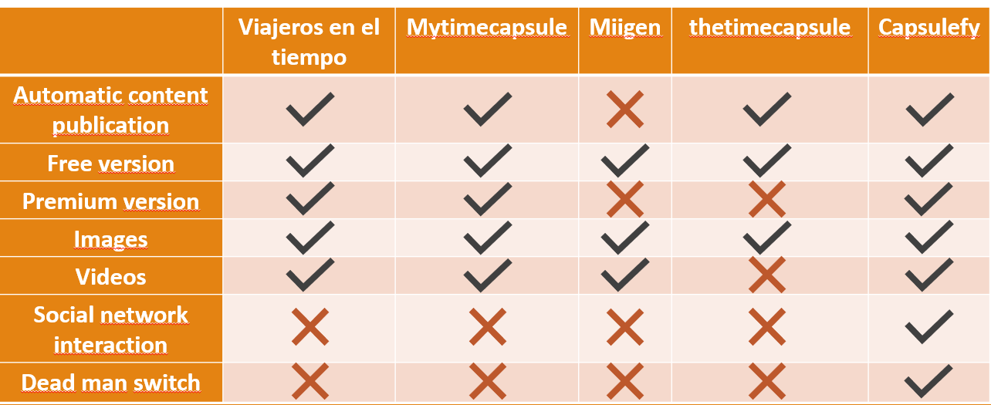

Figure 1: Competitors analysis table

We reached the conclusion that we are treading into an already existing market, but an undeveloped one, where we can offer features that makes us distinct from our competitors, such as the interaction with social networks and the publication of content in case the user has not logged in for a very long time.

There are other indirect competitors, such as official last wills or more traditional methods of sharing memories like photo albums, but they won’t be able to offer the possibility of quickly sharing their contents online.

The innovation of our app are these two features no other application similar to us provides: The dead man switch and social network interaction. While the development of these features does not imply that we are innovating from a technological viewpoint, since we will be using already existing technologies (OAuth, API calls…), the way we are incorporating them into our business model is something new that has not been tried by our more direct competitors. Thanks to these features, our service is highly customizable so that every user can tailor their time capsules to their needs.

# Project Launch tasks

The planned tasks in order to prepare ourselves for our project launch, along with their completion dates, are the following:

## Week 1 (May 13th- May 19th)

|  |  |  |  |  |  |  |
| --- | --- | --- | --- | --- | --- | --- |
| Task | Start date | Estimated end date | End date | Team member | Estimated time | Invested time |
| Initial meeting, review user’s feedback | May 13th | May 13th | May 13th | All members | 1.5h | 1.5h |
| Creation of social media accounts | May 14th | May 14th | May 14th | Juan R. | 0.5h | 1h |
| Identify target groups | May 14th | May 15th | May 16th | Pablo R. | 1.5h | 1h |
| StartUs tasks | May 14th | May 16th | May 16th | Adrián C. | 4h | 4h |
| Advertisement spot | May 14th | May 16th | May 16th | Daniel C. | 4h | 4h |
| Plan social media marketing | May 14th | May 16th | May 17th | Juan R. | 3h | 2.5h |
| Marketing strategy and costs | May 15th | May 16th | May 16th | Pablo R. | 2h | 2h |
| Update landing | May 16th | May 17th | May 17th | Daniel C. | 1.5h | 1h |
| Remake demo videos | May 16th | May 17th | May 17th | Adrian C. | 1h | 1.5h |
| Update costs | May 16th | May 16th | May 16th | Pablo R. | 1.5h | 1.5h |
| Carry out social media marketing | May 16th | May 19th | May 19th | Juan R. | 2h | 2h |
| Review populate | May 18th | May 18th | May 18th | Pablo R | 1h | 1h |
| PowerPoint | May 15th | May 19th | May 19th | Rafael F | 5h | 5h |
| Rehearsal | May 19th | May 19th | May 19th | Pablo R | 1h | 1h |

## Week 2(May 20th-May 25th)

|  |  |  |  |  |  |  |
| --- | --- | --- | --- | --- | --- | --- |
| Task | Start date | Estimated end date | End date | Team member | Estimated time | Invested time |
| Meeting to discuss class feedback | May 20th | May 20th | May 20th | All members | 1.5h | 1.5h |
| User advertisement spot | May 20th | May 22nd | May 22nd | Adrian C | 4h | 4h |
| Carry out social media marketing | May 20th | May 24th | May 24th | Juan R. | 1h | 1h |
| Investor’s advertisement spot | May 20th | May 22nd | May 22nd | Juan R,  Rafael F | 4h | 5h |
| Future improvements | May 20th | May 22nd | May 22nd | Daniel C F | 1h | 1h |
| Marketing costs | May 20th | May 22nd | May 22nd | Pablo R | 2h | 2h |
| Deploy application | May 22nd | May 22nd | May 22nd | Adrián C, Daniel C | 1.5h | 1.5h |
| Update Landing page | May 22nd | May 23rd | May 23rd | Daniel C | 0.5h | 0.5h |
| PowerPoint | May 21st | May 24th | May 24th | Rafael F | 5h | 5h |
| Project launch retrospective documentation | May 22nd | May 24th | May 24th | Pablo R | 5h | 4h |
| Rehearsal | May 26th | May 26th | May 26th | Pablo R | 1.5h | 1.5h |

# Target users

Our product is targeted to the following groups of people:

* People who regularly uses social media
* People with families, that may feel the need of leaving messages for their children, nephews, grandchildren…
* People with a decent amount of income: As what we are offering is a service who usually has not a direct effect and it is more oriented as a long time investment, those with cash to spare are more likely to purchase our service even if they have to wait for a long period of time to see the results
* As for the gender of our target demography, there are no apparent factors that may make man or a woman more likely to purchase our services.

Taking these factors into account, we have stablished our core target demography as a middle-class man or woman of 30-50 years, who is married or plans to and who has a close relationship with his family members, and that potentially has kids or plans to.

The reason why we are not counting elder people as part of our core target is because they are less likely to be tech savvy and use the internet regularly. This means that they may not trust our services or that they may be unable to make purchases as they might not have a PayPal account.

The reason why we are not counting younger people as part of our core target is because they are less likely to think in the long term, they may also not have that much cash to spare and usually they are not as focused on the family.

This does not mean that this kind of audience has no interest in our application: Elder people may be more interested in leaving a legacy behind, which is one of the main goals of our application and are more likely to be close to their family members. On the other hand, young people are more likely to trust an online service, and they are more used to make online purchases. Basically, we will have a bigger amount of elder people interested in the services we offer but only a small percentage would be willing to pay, while we will have a small amount of young people interested, but among those interested a high percentage of them would go through our payment process.

# Marketing campaign

Our goal is to advertise ourselves on the internet. We will manage social media accounts: Twitter, Facebook, Instagram, YouTube and LinkedIn accounts. We will also use the ads services provided by these social networks, mainly Twitter and Facebook ads. Besides social networks, we will make use of google ads to further advertise our product. Following our project launch, we will hold different special discounts and campaigns, which of course will be advertised in our social media.

## Advertisement budget

Our product is targeted to people who regularly uses internet and social media. The age segments targeted are young people and middle-age people.

Our goal is to advertise ourselves on the internet. For that reason, we will be using google ads. Because we offer integration with Facebook and Twitter, reaching out to the users of these platforms.

### Google ads budget

Google ads charge business for each time their advertising is clicked. Each business can set how much they can be charged, and depending the price set, their ad will be more visible.

We have made the following adjustments to the audience that will see our ads in google:

* The ad will be directed to people living in Spain
* Our business category will be “Cloud storage”
* The ad will appear to people who search the following terms: “Capsulas del tiempo online”, “Capsula del tiempo” and “Testamento digital”

This give us a potential audience size of 37,611 people each month.

When selecting how much do we want to be charged for our ads monthly, Google ads tells us that the usual budget of other similar products is between 128€ and 638€.

Because we are a small company, we will be settling for a small budget within that interval, around 220€ per month.

After setting up these parameters, we are informed that the estimated performance of our ad is 1,746 – 2,935 views and 137‑229 clicks per month. This means that each visit to our page we gain through google ads costs us 1,2 euros.

### Facebook ads budget

Facebook also allows us to customize how much would be willing to spend on a weekly basis.

We have selected the following target demographic:

* People between 30 and 50 years
* Parents and married people
* Interested in family
* People who has recently had a baby
* People with interested in friendship
* People who travel frequently

We have decided to spend about 140€ monthly for a Facebook advertisement. With the demographic we have established, we expect that our ad will receive 6,900 views each month, and 200 clicks monthly, which means that each visit to our site through Facebook will cost us about 1.4 euros.

### Twitter ads budget

Same as before, allows us to set a daily price.

We want to create a campaign focused on increasing the number of visits in our website. The target userbase will be men and women with an age of 25 to 49 year with the following interests: Travels with kids, luxury travels, mothers, fathers, parents of kids, upbringing of teenagers and holidays. The audience size of this campaign is about 600K people.

The recommended interval for the bidding is between 1.55 and 6.90 daily. We will be using a similar budget to the one for Facebook, 5€ daily, which means ~150€

### Total

We will be spending approximately 510€ monthly in advertisement. If in our project costs we are going to include the cost for the first 6 months, we will have a total cost of 3060€.

After these first 6 months, we will evaluate how this approach is performing, and depending on that we will decide whether increase or decrease our budget.

In order to know whether or not our marketing campaign is effective, we need to know how many sales we need to make in order to obtain profit from this investment. If we are to gain 9.5 euros per sale, we will need at least 53 sales each month thanks to this campaign. Assuming a conversion rate of 10%, that means that we would need 530 visits to our site gained through these adds. Less than that would mean that our campaign is not profitable.

## Social media publications

We will begin by posting content to our YouTube, Facebook and Twitter accounts, with the intention to expand our marketing to Instagram and LinkedIn in the future.

Our accounts in these social networks are:

* Twitter: @capsulefy.
* Facebook: Capsulefy Comms.
* YouTube: Capsulefy Project.

Our advertising spots are already published on our YouTube account. The links to these videos are the following:

* First user and client-oriented spot: <https://www.youtube.com/watch?v=hGK-HhkFT8g>
* Informative spot about what does our app do, oriented to any kind of person, user/client or investor: <https://www.youtube.com/watch?v=YvcHYHIvKt8>
* Investor oriented spot: <https://www.youtube.com/watch?v=dfMd4kan1NA>
* Second user-oriented spot: <https://www.youtube.com/watch?v=0bTN0LgzTRY>

Our first publication on Facebook and Twitter will be on May 22nd. We will post our videos already uploaded to YouTube along some messages advertising our launch

Afterwards, on May 26th, May 30th, June 3rd and June 7th we will make more publications, including demo videos showcasing our product. Whenever a special discount campaign is launched, we will use social media to gather more attention.

## Discounts and campaigns:

In order to generate interest in our app and get people to use it, we will have special discounts just after our final application is launched:

* During the first week, creating premium capsules will be free.
* Afterwards, there will be a discount of 25% when purchasing capsules for the first month. This means that if they usually cost 11.99€, their price during the first month will be of 8.99€.
* We want to add some campaigns where people can recommend the application to their friends and this way, both the person who recommends the application and whoever decides to give it a try will receive discounts. However, in order for this to happen we will need to update our product so that it supports a referral system. Because of this, we have decided to launch this campaign during Christmas Holidays, this way, we can tie the invitation to use our services with a campaign as a “present”. After Christmas Holidays, and therefore our campaign, ends, we will launch similar referral campaigns in special dates such as Saint Valentin, Father’s/Mother’s Day, etc.…

# Cost estimation

Because we will be using Google Firebase to store all the files our users will upload to our system, we need to take into account the individual cost per user. By using Amazon S3, we will be charged 0.026 USD per GB per month.

Assuming we will be offering 500mb of storage in each of our Premium/Modular capsules, the cost of maintaining each 500mb capsule yearly is 0.156 USD (0.14€).

Assuming free users have 20 mb of storage, the yearly cost of maintaining a free user will be of 0.00624 USD (0.0127€).

In order to decide our storage and hosting funds, we will consider the cost of maintaining 2,000 premium capsules and 20,000 free users for a year, as well as an estimation of the cost of hosting our website and our database.

Our team has come up with 4 different cost estimations: A pessimistic one, an optimistic one, and two realistic estimations. These estimations cover costs during the development of our product, whose duration will be of 4 months, and some funds which may be used in order to deal with the risks that appear during the development or to cover initial server and advertisement costs. The factors that will affect our budget are the following:

* Team members’ salaries.
* Hardware amortization.
* Advertising funds for the first 6 months.
* Storage and hosting funds for the first year.
* Risk prevention funds.
* Taxes.
* Maintenance and customer service for the first year

Because we will be using Google Firebase to store all the files our users will upload to our system, we need to take into account the individual cost per user. By using Amazon S3, we will be charged 0.026 USD per GB per month.

Assuming we will be offering 500mb of storage in each of our Premium/Modular capsules, the cost of maintaining each 500mb capsule yearly is 0.156 USD (0.14€).

Assuming free users have 20 mb of storage, the yearly cost of maintaining a free user will be of 0.00624 USD (0.0127€).

In order to decide our storage and hosting funds, we will consider the cost of maintaining 2,000 premium capsules and 20,000 free users for a year, as well as an estimation of the cost of hosting our website and our database.

As for advertising funds, firstly we have previously mentioned what is our estimated budget for the first 6 months and what benchmarks we expect to reach. We will be spending 3060€ during the first 6 months. Afterwards, we will see whether or not we have reached our benchmarks, which sources of ads has given us more relevance and which less and modify our spending accordingly.

One of the members of the development team will assume the responsibility of complying with the GDPR, with no effect to his salary, meaning that it won’t have an impact in our budget.

Regarding customer service, we will have one person in charge of it after development has ended, at a cost of 15K € a year. The person in charge of customer service will attend to the user’s issues, this includes the GDPR related petitions they may make, such as retrieving their personal data stored in our system.

Overall, we expect this project to have a cost of 45K euros approximately.

# GDPR

In order to comply with the GDPR regulation, our system offers the following features:

* A user who is registered may delete the capsules he has created, as well as delete all the data related to his account from the “My account” page.
* In case an external actor has data stored in our system by a third party without consent, by sending an email to [capsulefy.communications@gmail.com](mailto:capsulefy.communications@gmail.com) we will investigate the issue and delete said data.
* If suspicious activity is detected, affected users will receive an email in order warn that their accounts may be compromised. Attached to this email there is the url of the page in our website that allows users to change their password.
* A user can ask to receive all the data related to him stored in our system by writing to our contact email using the email address provided when registering to our system.
* Our site has a section that details all these options and explains the data from the users that we store and why we store it. It also contains information about the usage of cookies. A notification about cookie usage also appears when a user access to our site.
* When a user wants to register to our system, he must accept our terms of service in order to finish the sign-up process

With the exception of a user deleting his account and/or capsules, all these tasks are not automated. This mean s that the person in charge of system maintenance and customer service will be the one who manages the petitions of our users.

# Expenses of the project so far

After these two weeks of preparation for our project launch, our project is fully working and ready to be released. The only thing that is left is polishing some aspects of our business. At this point, the expenses are the following:

|  |  |
| --- | --- |
| Project duration | 13 weeks |
| Total spent in salaries | 13,390 € |
| Equipment | 325€ |
| Hosting | 669€ |
| Advertising | 3,060€ |
| First year maintenance | 15,000€ |
| Risk prevention fund | 2,724€ |
| Total costs | 3,5168 |
| Percentage of project completion | 95% |
| Percentage of budget spent | 78% |

Our costs have been less than what we expected. At this point, we have spent 17% less that what we had estimated, which means a deviation of 7,650 €

# Feedback received from our pilot users

At the end of our piloting plan, our pilot users received a final form in order to know their opinion about our product after these weeks of development: Whether they liked the final result or not, what things they think that could be improved in the future and what are the features they liked the most. After gathering the results, these were the opinions and ideas that were more common among the pilot users:

* It would be nice to able to connect the capsules with Facebook.
* We could implement some payment plans for families or similar promotions.
* Because we only have PayPal as the payment option, some of the pilot users think that we some people may not purchase our capsules if the don’t have a PayPal account.
* The pilot users think that the dead man timer is a very good idea and that it may have more users than we think, for example, setting up some messages in order to remind you about certain events or deadlines.
* Overall, they though our user interface was nice and easy to use. They had no problems when navigating our site and testing its features.

# Future improvements

There are additional features and improvements that we would like to add to our product after its launch. What will we prioritize is going to depend on the reception of our application. The same applies when deciding when are we going to start working on these improvements. At this moment, these are the improvements we have planned:

* Add more configuration parameters for the system admin in case we consider necessary to expand the size of the capsules or their price.
* Add the option to introduce discounts in the price of our capsules for certain campaigns. These events should be announced in our page and via social media.
* Allow the creation of special promotion codes or referrals to attract new customers
* Add more payment methods such as Stripe.
* Expand the social media integration to Facebook and Instagram
* Increase the number of metrics the administrator can see on the dashboard in order to monitor the state of our site
* Automation of some processes such as exporting and sending data from our users.
* Develop a system that allows the inheritance of accounts and credentials.

# Devising a business plan milestone initial planning

Because at this point our MVP is already fully working, it is not possible at this point in time to make a more specific planification for this sprint, as a big part of the tasks that will be assigned are related to the feedback we will receive from pilot users and improvements our team can think of.

## Week 1 (May 27th- June 2nd)

|  |  |  |  |  |
| --- | --- | --- | --- | --- |
| Task | Start date | Estimated end date | Team member | Estimated time |
| Initial meeting | May 27th | May 27th | All members | 1.5h |
| Study pricings and make changes if needed | May 28th | May 29th | Pablo R. | 1.5h |
| Improve SWOT analysis | May 28th | May 29th | Juan R. | 1.5h |
| Improve ROI estimation | May 28th | May 16th | Daniel C. | 2h |
| Come up with contingency plans for our expenses | May 28th | May 29th | Adrián C. | 3h |
| Short and long term plans | May 29th | May 31st | Juan R, Daniel C. | 3h |
| PowerPoint | May 29th | June 1st | Rafael F | 5h |
| Rehearsal | May 31st | May 2nd | Pablo R | 3h |

Afterwards, we will improve and expand the documentation of our project until its delivery on June 7th.

# Items produced as a result of this deliverable

Final version of our application, deployed on <https://capsulefy05.herokuapp.com>

Demo videos of our application, which can be found in our slides. The release of this sprint in GitHub can be found on <https://github.com/pabreblob/capsulefy/releases> (Release 5).

Advertising spots uploaded to our YouTube account (Capsulefy Project) and referenced in this document.

All the documentation related to these two weeks of preparation for the project launch.